# Steps:

1. git clone https://github.com/apache/superset.git

1. cd superset
2. docker compose up
3. sudo apt-get update
4. curl -fsSL https://download.docker.com/linux/ubuntu/gpg | sudo gpg --dearmor -o /etc/apt/keyrings/docker.gpg
5. sudo chmod a+r /etc/apt/keyrings/docker.gpg
6. sudo apt-get install ca-certificates curl gnupg
7. newgrp docker
8. docker run --rm -it -p 80:80 vulnerables/web-dvwa

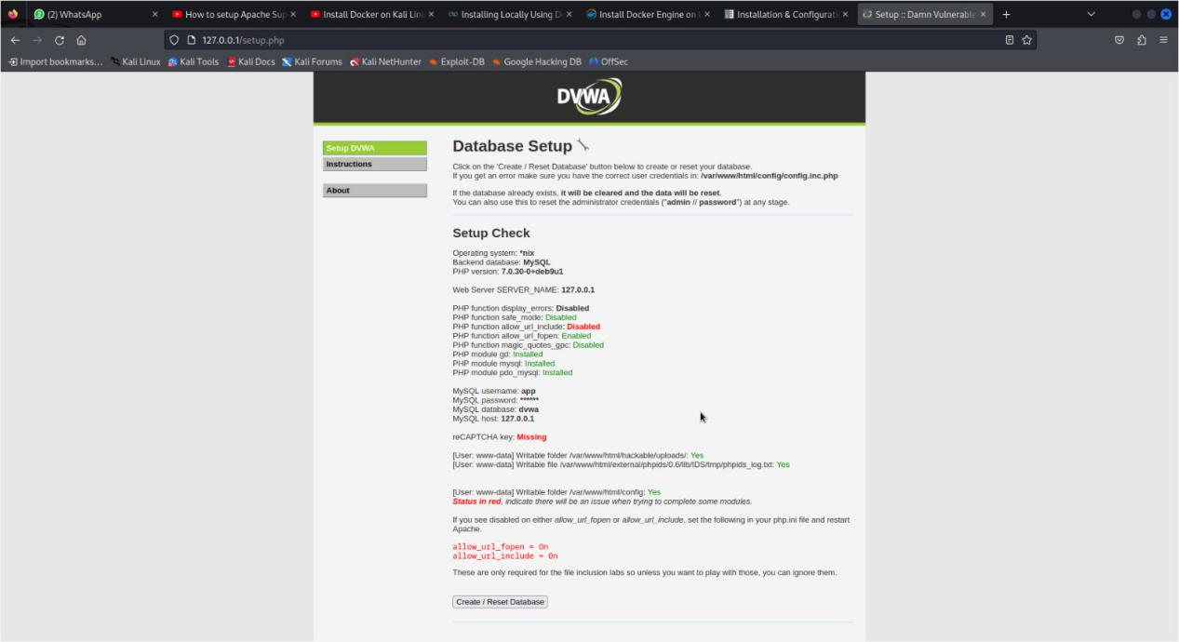

1. docker-compose -f docker-compose-non-dev.yml pull
2. docker-compose -f docker-compose-non-dev.yml up

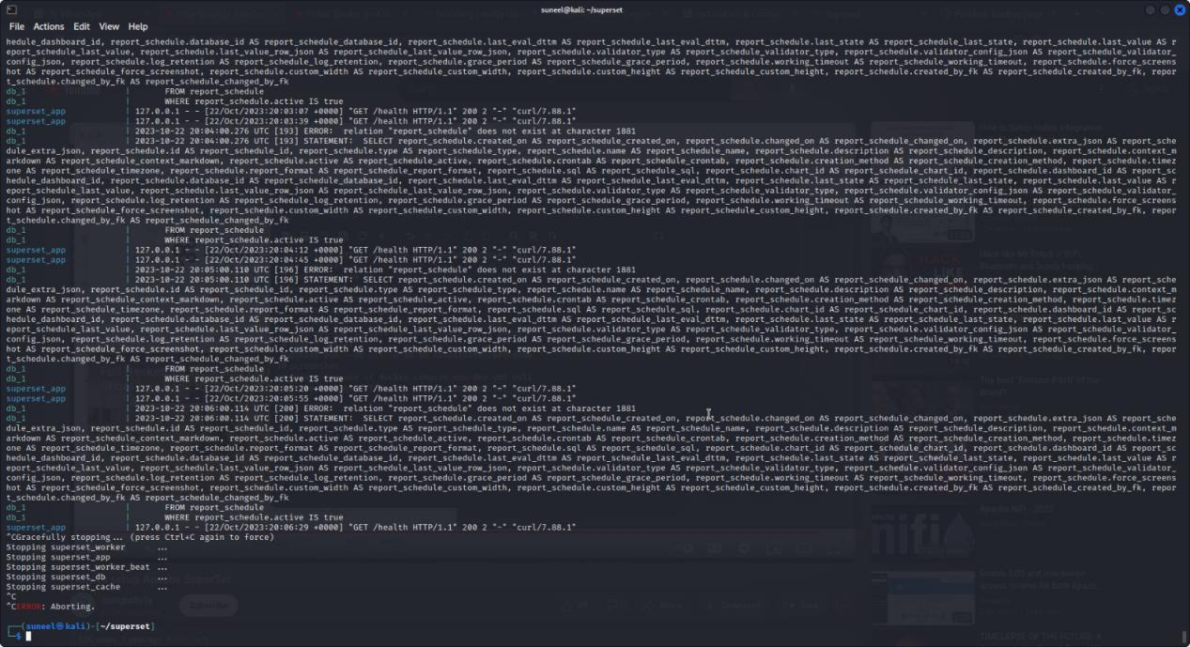

# Description:

This set of steps involves setting up an environment using Git, Docker, and various commands to run Apache Superset and other containers. First, you clone the Superset repository, navigate to the Superset directory, and start Docker Compose. Then, you update your apt-get packages and configure Docker for Ubuntu. You pull and run the "vulnerable/web-dvwa" container, and finally, you pull and start additional containers with a non-development configuration using Docker Compose.

Advantages of this method include ease of setup and configuration thanks to Docker, which simplifies the installation process for Apache Superset and related containers. Additionally, using version control with Git ensures that you have the latest code from the Superset repository.

However, there are some disadvantages. The commands require elevated privileges with 'sudo,' which can be risky if not managed properly. Additionally, these steps may not be suitable for all environments or operating systems, as they are specific to Ubuntu. Lastly, the security implications of running vulnerable containers like "web-dvwa" should be carefully considered, as they are designed for testing and educational purposes and may pose a security risk if not used responsibly.